**Requirements for test application**

**General:** Test application is purposed for collecting information about families, i.e. Husband, Wife and Children.

**Requirements questions:**

To R1:

1. Is it a web app?
2. Is it a mobile app?
3. Is it a desktop app within your company's software?
4. What operating systems does the app support?
5. What is the name of the application?
6. What is the app's Logo?
7. Does the application have a Help tab?
8. Does the app have a Privacy Policy tab?
9. Does the app have a Feedback tab?
10. Does the app provide the ability to work with the app for visually impaired people?
11. Can the app function without an Internet connection?
12. If an Internet connection is required, what is the minimum Internet connection speed?
13. When refreshing the page, should the data about the last operation be saved?
14. When disconnecting the Internet connection, should data about the last operation be saved?
15. When rebooting, should the data about the last operation be saved?

To R2:

1. What file formats are provided in the application?
2. What font type and size does the app support?
3. What are the name’s file requirements?
4. In which directories can the file be saved?

To R3:

1. How many apps can be launched simultaneously?

To R4.1:

1. Why do “New, Open, Save” buttons should be eligible also for other three tabs: Husband, Wife, Children?

To R5:

1. Is the Description field required?
2. Is the Date of marriage field required?
3. If a required field is not filled, should the alert message "Field is not filled" appear?
4. How many times should the user click on the New button to perform action?
5. What type of calendar?

To R6:

1. How many times should the user click on the Open button to perform action?

To 6.1:

1. Should the application propose to Save the current database (changes)

if the user is editing new (or opened) database and then clicks ?

1. Is it possible to edit an existing database?

To R7:

1. How many times should the user click on the Save button to save a current database?
2. Is it possible to select a directory to save the file?

To R7.1:

1. What does "clearly visible for the User" mean?
2. Where should the name’s file be clearly visible to the user?

To R7.3:

1. What is the alert message if the user saves a database under the name which already exists in the path?

To R8:

1. What languages ​​should the app support?
2. What is the default language?

To R10:

1. How many times should the user click on the Нusband tab to perform action?
2. Should the screen Husband have three hinted buttons Add, Del, Edit?

To R10.1:

1. Where is BR3?
2. What fields are required?
3. What fields are not required?
4. If a required field is not filled, should the alert message "Field is not filled" appear?

To R10.2:

1. What is the format of the Age field?

To R11:

1. What attributes of Wife might be filled in?
2. What fields are required?
3. What fields are not required?
4. If a required field is not filled, should the alert message "Field is not filled" appear?
5. Should the screen Wife have three hinted buttons Add, Del, Edit?

To R12:

1. How many times should the user click on the Children tab to perform action?

To R13:

1. What is the name of column 3?

To R13.1:

1. How can the user select cells?

To R14:

1. What is the maximum number of lines a user can enter?

To R17:

1. Where is BR3?
2. What fields are required?
3. What fields are not required?
4. If a required field is not filled, should the alert message "Field is not filled" appear?

To R18:

1. What is the alert message if the user clicks on the Del Child button?
2. How many times should the user click on the Del button to perform action?

To R18.1:

1. This requirement is not correct.

To R19:

1. What attributes should appear if the user clicks on the Edit Child button?

**BR questions:**

To BR1:

1. What is the date format of the field Date of marriage?
2. What does "normal size" of Calendar mean?
3. What does "be user-friendly" mean?

To BR2:

1. Is it possible to enter upper case letters in the Description field ?
2. Is it possible to enter lower case letters in the Description field?
3. Is it possible to enter space in the Description field?
4. What characters are allowed for input in the Description field?
5. If more than 50 characters are entered, should an over character alert message appear?
6. Is it possible to enter the copied data from the clipboard?

To BR4:

1. Is it possible to enter space in the field “Height”?
2. Is it possible to enter zero in the field “Height”?
3. Is it possible to enter negative numbers in the field “Height”?
4. Is it possible to enter fractional numbers in the field “Height”?
5. If more than 300 cm is entered, should an over character alert message appear?

**Inconsistencies in requirements, BR and Sketches:**

1. The names of the buttons New Database, Open Database, Save Database in R4 do not match the names of the buttons in R4.1 (New, Open, Save) and so on in the text;
2. The names of the tabs Wife, Children in R4.1 do not match the names of the tabs in Sketch 1 (wife, Child);
3. The name of the field Date of marriage does not match the name of the field in Sketch 1 (Date of mariage);
4. Column name does not match the quantity in R13 (3 columns should have names “Name” and “Height” consequently);
5. The names of the columns in R13 (Name, Height) do not match the names of the columns in Sketch 3 (Name, Height, BirthDay);
6. The names of the columns in R13 (Name, Height) do not match the names of the columns in R17 (Name, Height, BirthDay);
7. In Sketch 3, there is no scroll, indicated in R15 (scrolling functionality should be available on this page);
8. The R5 states that the Marriage Date of marriage selected using a Calendar, but BR1 states that the date can be be typed manually or selected using the Calendar pop-up;
9. The R10.2 states that the field Age should be calculated by application as soon as Birth Day is filled in, but in BR1 states that the Date can be blank;
10. The BR4 states that the label cm should exist in the form, but there is no label in the Sketch 3;
11. The BR4 states that the should be entered manually or using Calculator pop-up, but in the Sketch 3 there is no Calculator pop-up;
12. The presence of a Сalculator pop-up in the BR4 is not correct. If BR4 indicates height in cm, what is the need to use the Calculator?
13. The Sketch 3 is in English, but the line contains the name in Russian;
14. The R6.1 states that the user can edit the database, but the R9 states that the application allows only fill information about family and save it in a database and Application doesn’t allow working with existing databases;
15. The R18.1 conflicts with R18.

**Sketch 1**

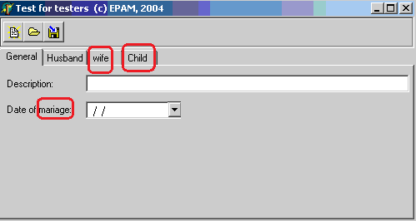

**Sketch 2**

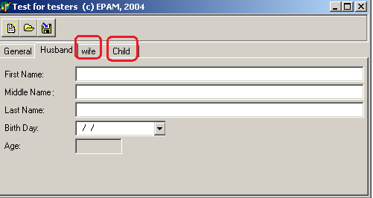

**Sketch 3**

